One Stone to Another
By Joseph D. Kubal
As you may know or not, I have been working on a book about Route 66 between Chicago and Joliet. Even here, I cannot separate myself from one of my passions – rocks. I have an interesting story to tell, one of transition and history of quarries in Chicago.
Many of you probably have wandered around the Illinois and Michigan (I&M) Canal cities of Lemont, Lockport and Joliet. You may have noticed many buildings in these towns made out of a creamy, buff-colored stone. This is Joliet-Lemont limestone (JLL) and this is how the story begins. However, the location of the story has origins in early Chicago.
When the first settlers arrived in the Chicago area, they probably noticed outcrops of bedrock, which in some places, is scantily covered with a thin layer of glacial debris. The first quarries of the Niagaran formation dolomite, dubbed JLL locally, developed to provide a source of lime for farmers’ fields. The lime was used to “sweeten” acidic soils. Lime from these original quarries also was used for sanitation purposes needed to combat cholera epidemics. However, the stone in the immediate Chicago area was of poor quality for use as building material.
We now travel down the road to the Lemont area where the I&M Canal was being built in the late 1830s-1840s. While digging the canal, bedrock was encountered. It was discovered that this stone could be used to line the walls of the canal in a cost effective manner as it was readily available. It probably was shortly after that that JLL was found to be excellent for building purposes. JLL was used as the primary building material in Lockport’s acclaimed Gaylord (1838, 1859)and Norton (1855) Buildings which sit astride the I&M Canal in the town.
Before we proceed, we should clear up any misperceptions. JLL has been called many things. Its names include Lemont limestone, Athens marble, Joliet limestone, Sugar Run dolomite, Joliet marble, Niagaran dolomite, and Magnesian limestone (archaic), as well as other combinations and naming conventions. However, it should properly be called dolomite, irrespective of the local name.
Laid down during the Silurian age, about 440-420 million years ago, JLL was formed in the same sedimentary process as other limestone. The difference is that Joliet-Lemont stone is chemically composed of calcium magnesium carbonate [CaMg(CO₃)₂] versus simpler calcium carbonate [CaCO₃]. JLL is a true dolomite and not just limestone. As can be seen in its chemical formula, dolomite contains magnesium whereby some of the calcium has been replaced. Note that even though the stone is sometimes referred to as marble, it is not. Marble is a metamorphic rock and this type of rock is not found in Illinois. By convention, JLL was sometimes called “marble,” which is considered a more desirable building product, and was referred as such by the quarries around the cities of Joliet and Athens (now Lemont) in order to elevate their product’s status above those of others. Yes, there were marketing ploys even back then. Even though the rock has been exposed to be dolomite, I am using the common term JLL in this tale. Now back to the story.
JLL, as mentioned, was used for many buildings in the canal towns. The Illinois State Penitentiary (1858) in Joliet used stone quarried just across the street and, later, St. Mary Nativity’s church foundation (1906) was quarried in situ. The stone soon found favor throughout the area and many of Chicago’s pre-fire buildings were constructed using JLL. The most famous example of this still standing is in Chicago’s most famous landmark – The Chicago Water Tower and Pumping Station (1869). The use of JLL blossomed and it was used throughout the region. It was readily available, easily transported by barge or by train, and labor costs were low due to the large number of immigrants settling in Chicago at the time who were eager to find employment in the quarries.
The Great Chicago Fire of 1871 changed everything. “Newspaper accounts from the time, however, report that during the fire, limestone ‘seemed as though [it] actually burned like wood.’ Builders were so prejudiced against the local stone, most of which came from nearby Joliet and Lemont, that in the first thirty days after the fire, most ordered brick from as far away as Philadelphia. In the following year, builders worked extensively with sandstone from southern Ohio.” (Williams, p.130) In addition, JLL is subject to exfoliation and weathering and many of the older buildings that used the stone were showing signs of age which also put a damper on new construction.
Enter Indiana Limestone. There was a need to rebuild Chicago after the fire and local quarries could not keep up with the demand even though the reputation of the local stone was tarnished. Even so, the predominant Catholic church, Holy Name Cathedral (1875), was built out of JLL. JLL’s popularity, however, waned in the post-fire years. Indiana limestone, a pure homogenous gray Mississippian Period (360-325 million years old) limestone immediately began to supplant JLL as the building material of choice. The Indiana Limestone Institute of America, Inc. lists six specific advantages to the use of Indiana limestone as a building material – natural beauty, complementary, consistency, versatility, durability, and cost effectiveness. And Indiana limestone was aggressively marketed as a superior product.
In Chicago and across the nation, Indiana limestone found great favor. Notable buildings that utilize Indiana stone include: New York’s Empire State Building, the original Rockefeller Center, Grand Central Terminal, and Yankee Stadium; Washington D.C.’s Pentagon, National Cathedral, and more recently the United States Holocaust Memorial Museum; most of Indiana’s 92 courthouses; 35 of the 50 or 70% of all U.S. state capital buildings, and many colleges and university buildings. In Chicago, it was used for buildings such as the Fourth Presbyterian church, Tribune Tower, Auditorium Building, and the Michigan Avenue Bridge as well as in construction of residential dwellings such as “greystones.” In fact the use of Indiana limestone is omnipresent; it is dubbed “America’s Building Stone” by David Williams in his recent book.
By the 1940s the last documented building to be built entirely of JLL was constructed. That was All Saints Greek Orthodox Church of Joliet. In contrast, Indiana Limestone just was used in the construction of the National Hellenic Museum in 2010-11 in Chicago’s Greektown neighborhood.
Today, there are still quarries in McCook, Hodgkins, and Romeoville and scattered elsewhere throughout the region. However, since the early 1900s, the JLL industry evolved to today producing aggregate, i.e., crushed stone primarily for roads, riprap, and cement. Some of the existing Chicagoland quarries also reverted to producing lime again.
P.S. In 1971, Salem [Indiana] Limestone was designated the State Stone of Indiana.
The information in this article has been excerpted in part from the upcoming book, The Curious Traveler’s Guide: Route 66 in Metro Chicago, by Maria R. Traska, Joseph D. Kubal and Keith Yearman. Additional information can be found on their blog site at http://curioustraveler66.wordpress.com/.

Bibliography
Bradbury, James C, Deborah J Slaton, Joseph La Rue, Donald G Mikulic, and Vincent L Michael. Preservation of an Historic Building Material: Joliet-Lemont Limestone. Booklet, Chicago: Landmarks Presevation Council of Illinois, 1988.
Encyclopedia of Chicago. Quarrying, Stone Cutting, and Brick Making. 2005. http://www.encyclopedia.chicagohistory.org/pages/1031.html (accessed March 15, 2013).
Indiana Limestone Institute of America, Inc. About Indiana Limestone: Advantages. 2013. http://www.iliai.com/pages/Advantages (accessed March 14, 2013).
Lamb, John M. "Joliet Limestone: The Rise and Fall of a Nineteenth Century Building Material and Its Architectural Impact on the Joliet, Illinois Area." Quarterly Publication. Lockport, IL: Will County Historical Society, Winter 1997. 268-274.
Wikipedia. Dolomite. March 6, 2013. http://en.wikipedia.org/wiki/Dolomite (accessed March 15, 2013).
—. Indiana Limestone. December 11, 2012. http://en.wikipedia.org/wiki/Indiana_Limestone (accessed March 14, 2013).
—. Limestone. February 25, 2013. http://en.wikipedia.org/wiki/Limestone (accessed March 14, 2013).
Williams, David B. "America's Building Stone - Indiana Limestone." In Stories in Stone, by David B. Williams, 112-132. New York: Walker Publishing Company, Inc., 2009.

SEE PHOTOS BELOW
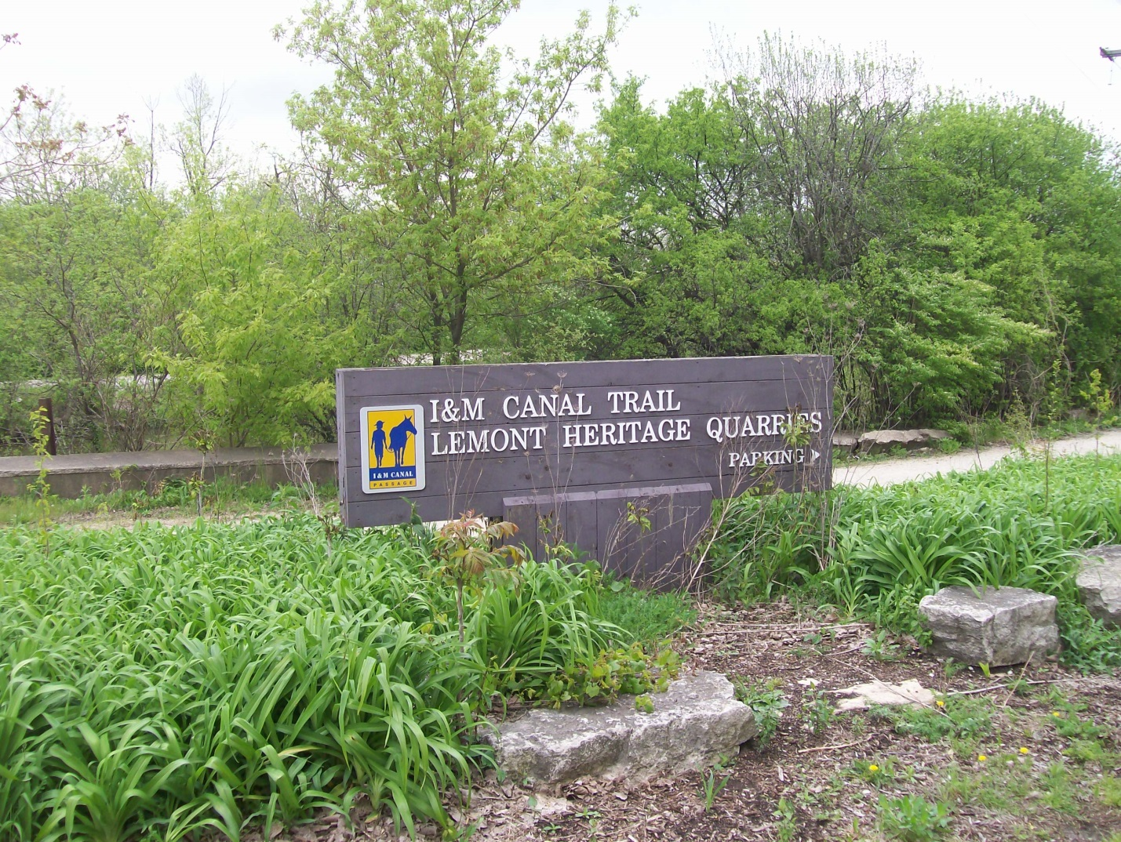
Trail park in Lemont featuring historic quarry area ©2012 Joseph D. Kubal - All Rights Reserved.

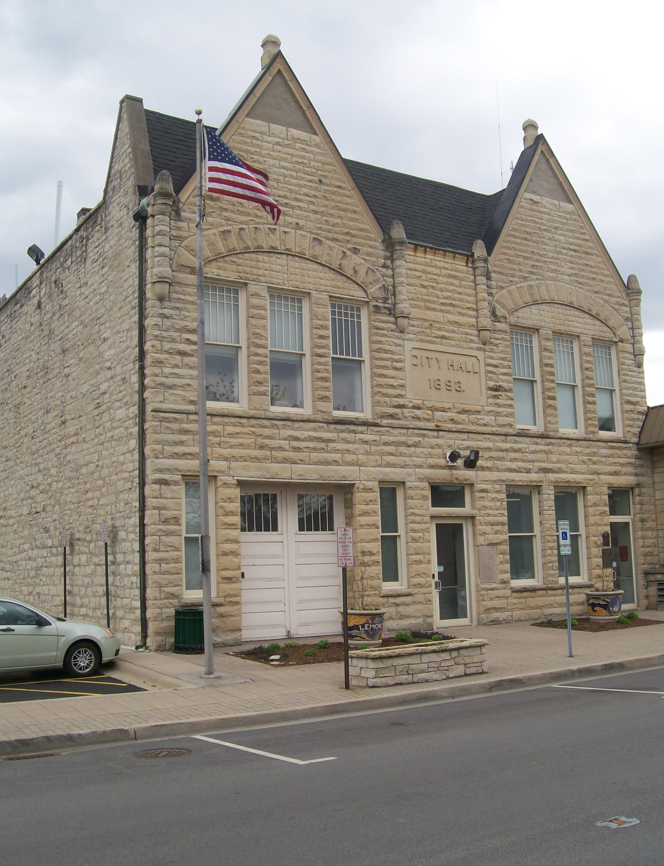
Lemont City Hall (1893) built of local “Athens” marble ©2012 Joseph D. Kubal - All Rights Reserved.
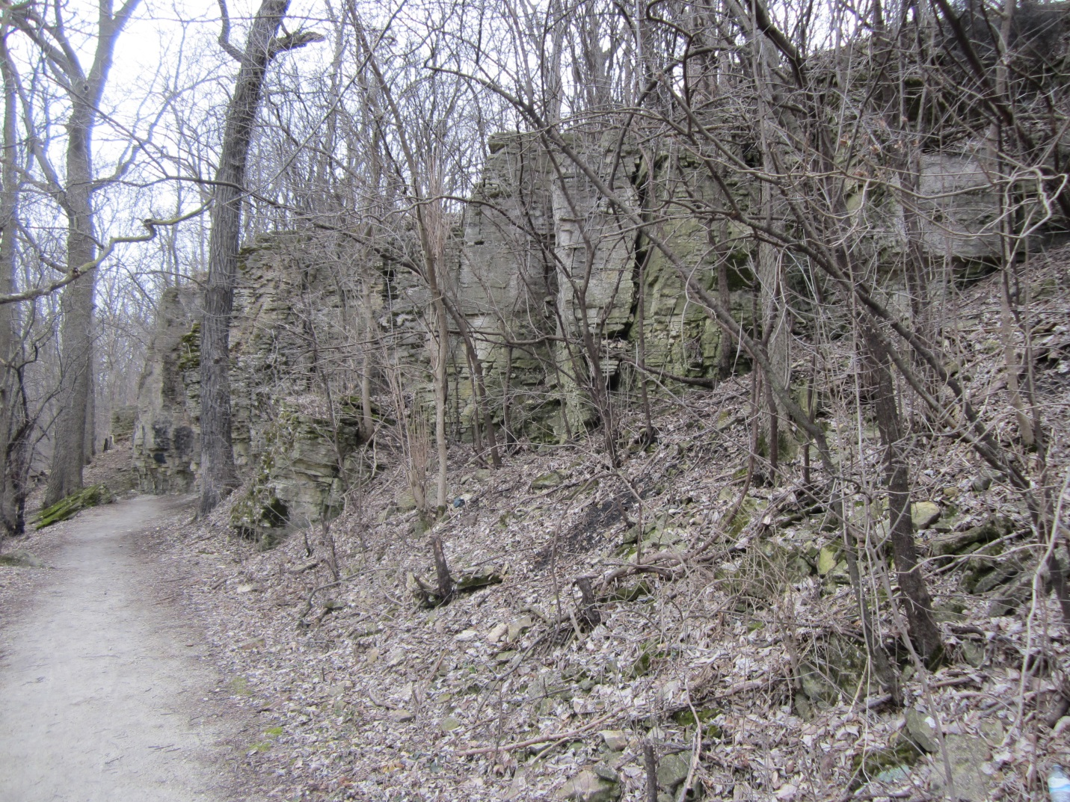
Outcrop of Lemont limestone in Lockport’s Dellwood Park ©2013 Joseph D. Kubal - All Rights Reserved.

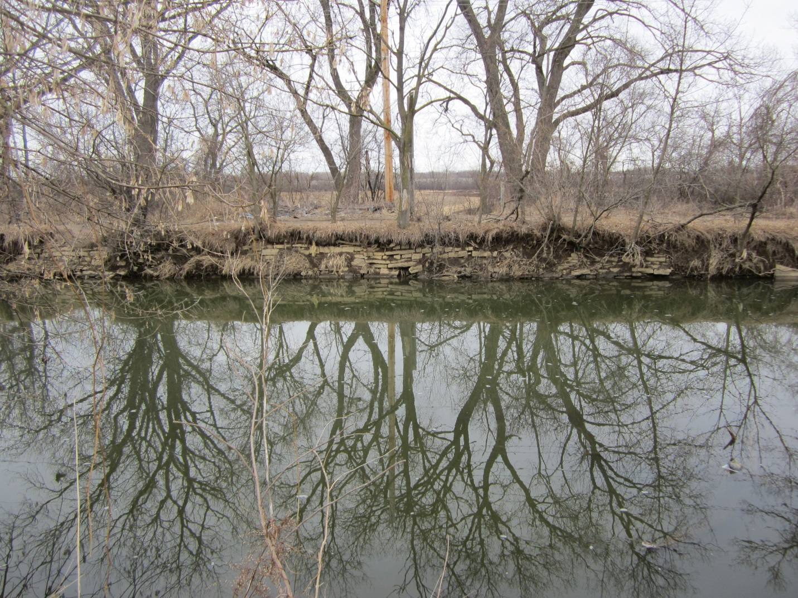
Walls of I&M Canal by Lockport lined with local limestone ©2013 Joseph D. Kubal - All Rights Reserved.

